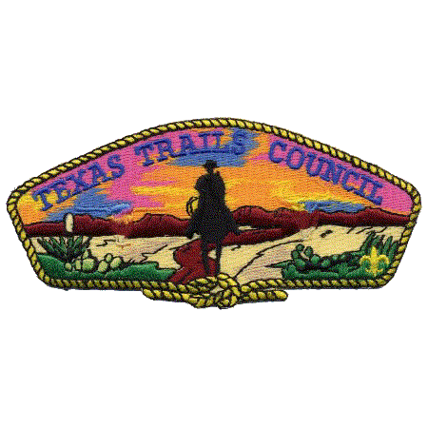

TEXAS TRAILS COUNCIL
SCOUTSING AMERICA
Cub Scout
DAY CAMP
Leaders Adventure Guide

CAMP TONKAWA
June 11-12, 2026

Texas Trails Council
3811 N. 1st St.

Abilene, Texas 79603
(325) 677-2688
www.texastrailsbsa.com

WELCOME TO CUB SCOUT DAY CAMP

Camp Tonkawa is nestled under huge Oak trees in southern Taylor County, Texas. Located about 12 miles south-southwest of Abilene and about 4 miles west of Buffalo Gap, the camp is on FM 89 next to the Abilene State Park.

Camp Tonkawa is a perfect setting for Cub Scouting events, such as Cub Scout Day Camp, Cub and Webelos Resident Camp. These activities are designed for young Scouts to spend time outdoors, having fun as they learn. Camp Tonkawa is an over 200-acre tract of land dedicated to offering Scouts the chance to experience the beauty of the outdoors and enjoy adventure.

Camp Tonkawa is a camp where the Spirit of Scouting is still strong. Songs, campfires, fellowship, and outdoor adventures make it an excellent Scouting adventure for Scouts of all ages.

The Texas Trails Council Camping & Outdoor Programs Committee welcomes you to this Texas Trails Council Camp! We are proud of Scouting America’s history and pledge our support to you in helping develop Scouts into responsible young people. We thank you for making a significant personal commitment of your time and talent to serve these youths and help instill the values of Scouting through an outdoor program.

This year’s theme: “BUG HUNTERS!”

Camp Tonkawa offers a wide variety of fun and challenging programs for your units. Scouts will have the opportunity to meet new people and have great adventures that will help them on their trail in Scouting. The camp program areas are staffed by fellow volunteer Scouts who are eager to teach.

This year we will also spend a day at the Buffalo Gap Presbyterian Camp located in the heart of Buffalo Gap: 700 Litel St, Buffalo Gap, TX, 79508. You do not want to miss this unique opportunity! This will be a family picnic day, so plan to bring the whole family.
PLANNING YOUR CUB SCOUT DAY CAMP ADVENTURE
Safeguarding Youth Training: Cub Scout
Cub Scout parents or legal guardians taking part in a Cub Scout program with their own child or legal ward are not required to register as leaders. All adults must review the “How to Protect your Children from Child Abuse: A Parent’s Guide” that can be found in the front of each Cub Scout Handbook. In addition, the parent or legal guardian must be accompanied by a registered leader at any time they are with youth members other than their own child/ward. All other adults must be currently registered in an adult fee required position.

Release and Indemnity/Hold-Harmless agreement
All adults must complete the agreement (attached in this parent’s guide). Your children may be listed on one of the parent’s forms. It must be completed and ready to turn in when you check in to camp.

Registration for Day Camp
Can be completed online by going to www.texastrailsbsa.org and clicking on the Cub Scout Day Camp button in the calendar of events. You may also sign up in person at the Scout office using the attached registration form. If you want to register as a unit, please contact the Scout office at 325-677-2688.

Day Camp Fees

Youth  $25.00 | Adults  $10.00

There are no part-time or day rates for camp; all pay the full fee.

The Texas Trails Council, Scouting America provides program, facilities, and services without regard to race, color, national origin, age, gender, or handicap. However, all leaders and youth on the camp must be current registered members of Scouting America. All part-time leaders that will be on the camp must be current registered members of Scouting America. No camper, youth or adult, will be permitted to stay in camp unless their full camp fees have been paid prior to the start of their camp session.

Camperships and Financial Need
Financial aid is available to help Scouts and families in need of financial assistance. Campership Application forms are available at the Texas Trails Council office and in this guide. Financial aid is not designed to pay the entire camp fee for the Scout. The family, pack, and/or chartering institution should pool their resources first with a financial aid request designed to meet the balance required. Remember, every Scout should be able to attend camp regardless of his or her personal financial circumstances.

Camp Pack Leader and Full/Part Time Leadership
The person in charge of your Pack must be at least 21 years of age. There are no exceptions. In addition, it is the policy of Scouting America that outings may never be led by only one adult. Everyone MUST have current Safeguarding Youth Training. The result is more fun for the adults and a better program for the Scout. Preferably, the Pack should be under the leadership of its registered Cubmaster. If the Cubmaster is unable to attend full time, the Pack committee should name a Camp Pack Leader. The Camp Pack Leader should participate in the leader’s meeting and assign and coordinate the responsibilities for all the adult leadership at camp for your unit.
Usage of Motorized Carts Policy
From time-to-time, youth and adult members with disabilities may have a challenge with the amount of foot-travel that is required to participate in the programs at camp and need special assistance in the form of a motorized cart while at camp. To protect all Scouts and Leaders while in Camp, the following guidelines have been established for the use of motorized vehicles such as golf carts, electric scooters, etc. for transportation of individuals with limited mobility. On the Scout or Leader’s Camp Physical, the need for a motorized vehicle must be noted by the signing physician. This should also be listed on the “Special Request” form located at the end of this guide; turned in by June 8, 2026.

- Personal vehicles are not allowed, unless they are designed specifically for a scout or leader with a disability.
- The assigned driver of the vehicle shall be over the age of 21 and the youth member shall not operate the vehicle by themselves.
- The vehicle is solely for the transporting of the Scout with a disability. Additional riders or operating the vehicle for other purposes will NOT be permitted.
- The camp will NOT provide vehicles for use.

Swim Checks and Pool Orientation
Following your unit’s Swim Check, each unit will receive a short pool orientation. During swimming pool orientation, Scouts will be shown how to “check-in” and will be informed about the rules and regulations that are to be followed during free swims. You will also be given a swim test during orientation time.

Daily Check-In Procedures
Day campers and adults should plan to arrive between 7:30 and 8:00 am each day. This year, day camp will take place in two different locations.

June 11 – Camp Tonkawa – Report to the Dining Hall
June 12 – Presbyterian Encampment, Buffalo Gap – Report to the Pool Pavilion

The top unit leaders will register the unit and should have with him/her:
- Verification of participants on the unit roster
- Sexual Predator report from the Texas Department of Public Safety for each adult
- Proof that each adult has current Safeguarding Youth Protection

Daily Check-Out Procedures
Day campers and adults should plan to check-out between 5:00 and 5:30 pm each day. This year, day camp will take place in two different locations.

June 11 – Camp Tonkawa – Sign out in the Dining Hall
June 12 – Presbyterian Encampment, Buffalo Gap – Sign out in the Pool Pavilion

Anyone taking a Scout from camp must show picture ID. If the person is not a parent or guardian, they must have written authorization from the parent and signed by the parent to transport the Scout.

Everyone must sign-in and out each day on the designated form.

Meals
Meals will not be provided. Plan to send a sack lunch and snack for both days.

What About Camping?
Cub Scout Day Camps are designed for day use only. Camping will not be available at Camp Tonkawa for this event.

MEDICAL TREATMENT NOTES
The Health and Safety of all Scouts and Leaders attending is the priority of our operation while they participate in outdoor programs at our summer camps. The following information is provided to familiarize you with camp medical policies and procedures.

Annual Health and Medical Record: Forms A and B
For any and all Scouting activities, all participants must complete Part A and Part B (both pages). “All participants” includes parents, guardians, siblings, youth, staff, and unit leaders. Though Part C is only required for participation in events lasting longer than 72 hours, all Scouting America participants are encouraged to complete this pre-participation physical during an annual exam performed by a licensed health-care provider.

Non-Emergency Transportation
Each Pack must provide transportation to and from the Local Health facilities in non-emergency situations. If transportation is not available from the Pack, check with the Camp Director or Health Officer for assistance.

Prescription Medication
All prescription medication will be kept in the Camp Health Lodge unless it is an Epi-Pen, rescue inhaler, or other “immediate need” medication. Also, please note that needles used for insulin injections or other prescribed medications must be placed in the biohazard container located in the health lodge. The Health Lodge will provide cold storage for medications requiring refrigeration.

Special Needs
Any Scout or Leaders with needs that require accommodation while at camp, need to tell us in advance of those services and the type of need, i.e. physical, medical, dietary, allergies, etc. Food allergies and dietary requests should be turned in by June 8, 2026. Please use the “Special Request” form located at the end of this guide.

Unit First Aid Kits
Everyone should be familiar with basic first aid. It is important that each Pack be prepared to treat minor cuts, scrapes, and abrasions. Bandaged wounds should be kept clean to aid in preventing infection, especially in an outdoor setting. The following is a list of recommended contents for a Pack first aid kit:

One 4” Roll of Bandage | One 2” Roll of Bandage | Two Rolls of 1” Tape
Two Triangular Cravats | Four Elastic Bandages | Antibacterial Soap
One Box of Assorted Band-Aids | Twelve 4x4 Sterile Pads | Scissors
Six Pairs of Latex Gloves | Twelve 2x2 Sterile Pads | Needle and Tweezers
Safety Pins | Sunburn Lotion | Tylenol/Non-Aspirin Tablet
Index Cards | Scotch Tape

RULES FOR SAFETY AND CONDUCT

- Speed limit is 10 MPH on ALL camp roads.
- Park only in designated areas. No parking of personal vehicles in camping areas.
- No passengers can ride in the bed of a pick-up truck.
- DO NOT LITTER. Please dispose of trash properly.
- Bag all trash – Do not stack loose rubbish on top of the bin. Place tied trash bags at the entrance to the campsite for pickup.
- Do not place embers or charcoal into the trash bins. Use appropriate means to extinguish fires.
- Swimming Pool, COPE Area, and Tonkawa Tower are OFF-LIMITS.
- Possession or consumption of alcoholic beverages is NOT permitted.
- Possession or consumption of illegal drugs is NOT permitted.
- Fireworks, and Personal Firearms are NOT permitted.
- Pets, except for registered service animals, are NOT permitted.
- Camp Tonkawa is a smoke free property. Tobacco products (cigarettes, cigars, vaping devices) are not allowed in camping areas or program areas. Please NO smoking or vaping during programs or Campfires. Be courteous to your fellow scouts!

Schedule*

June 11, 2026 – Camp Tonkawa
07:30am – 08:00am Check-in at “The Hive” Dining Hall
08:15am – 08:25am Opening Flags
08:30am – 09:55am Activity Station 1
10:00am – 10:25am Snack at the “Butterfly Garden” Trading Post Pavilion
10:30am – 11:55am Activity Station 2
12:00pm – 12:55pm Lunch in “The Hive”
01:00pm – 02:25pm Activity Station 3
02:30pm – 02:55pm Snack at the “Butterfly Garden”
03:00pm – 04:25pm Activity Station 4
04:30pm – 04:45pm Closing Flags
05:00pm – 05:30pm Check-out at “The Hive”

June 12, 2026 – Buffalo Gap Presbyterian Camp – Family Picnic Day
07:30am – 08:00am Check-in at “The Lily Pad” Ool Pavilion
08:15am – 08:25am Opening Ceremony
08:30am – 09:55am Swim Tests and Pool Orientation at the “Frog Pond”
10:00am – 10:25am Snack at the “The Lily Pad”
10:30am – 11:55am Den Specific Swimming Adventure “Frog Pond”
12:00pm – 12:55pm Lunch in “The Hive”
01:00pm – 02:25pm Raingutter Regatta at “The Lily Pad”
02:30pm – 02:55pm Snack at the “The Lily Pad”
03:00pm – 04:25pm Free Swim “Frog Pond”
04:30pm – 04:45pm Closing Ceremony
05:00pm – 05:30pm Check-out at “The Lily Pad”

*Tentative schedule subject to change

Camp Tonkawa Activities include:
Archery “Precision Stinger” at the Archery Range
STEAM “Painted Moth” at Beaver Lodge
Obstacle Course “Ant Trail” at the Pavilion
Cub Scout Skills “Mantis Manner” at Baden-Powell

Presbyterian Camp Activities include:
Swim Test and Swimming “Frog Pond” at the Ool
Raingutter Regatta “The Lily Pad” at the Ool Pavilion

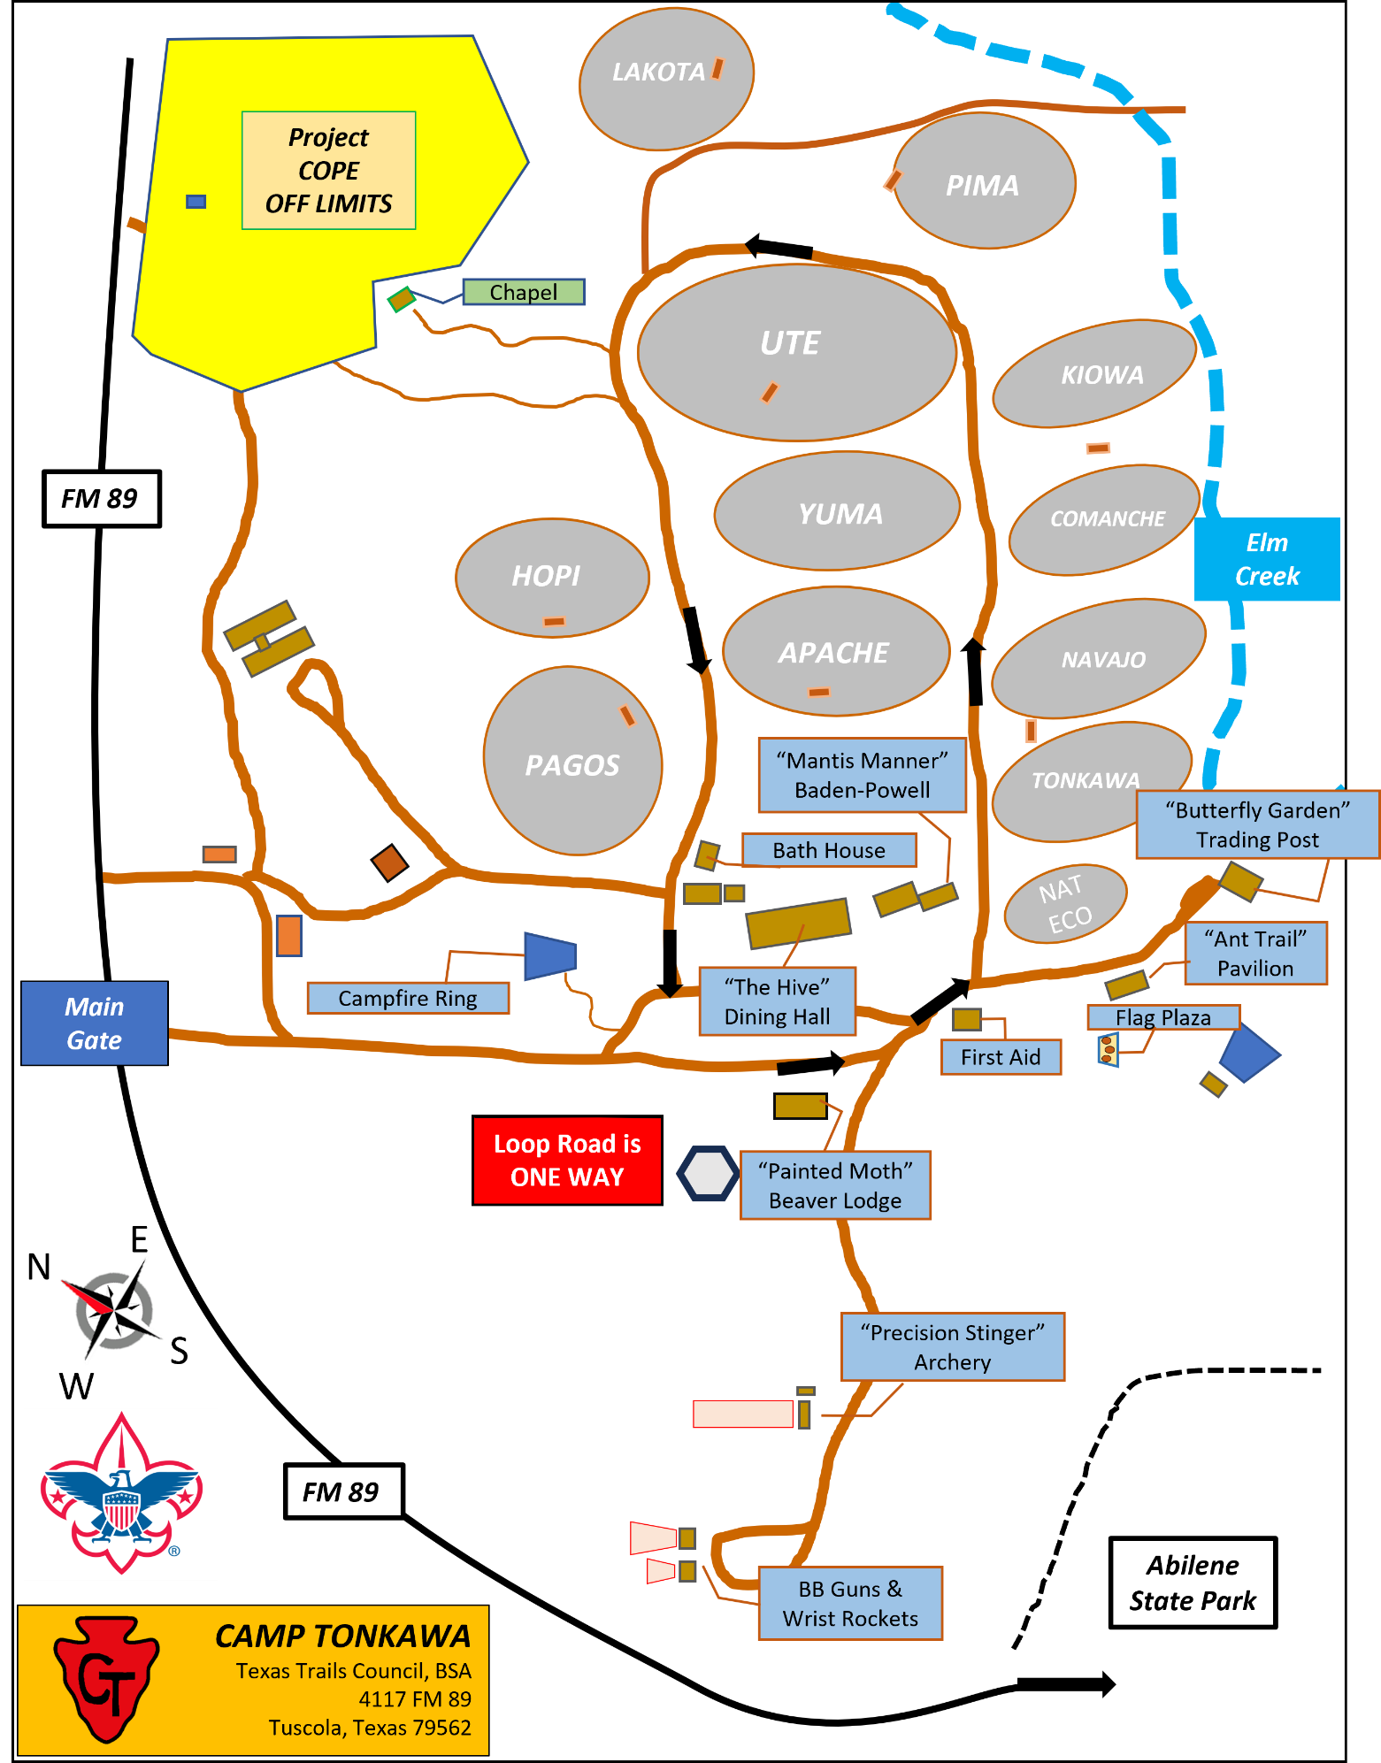

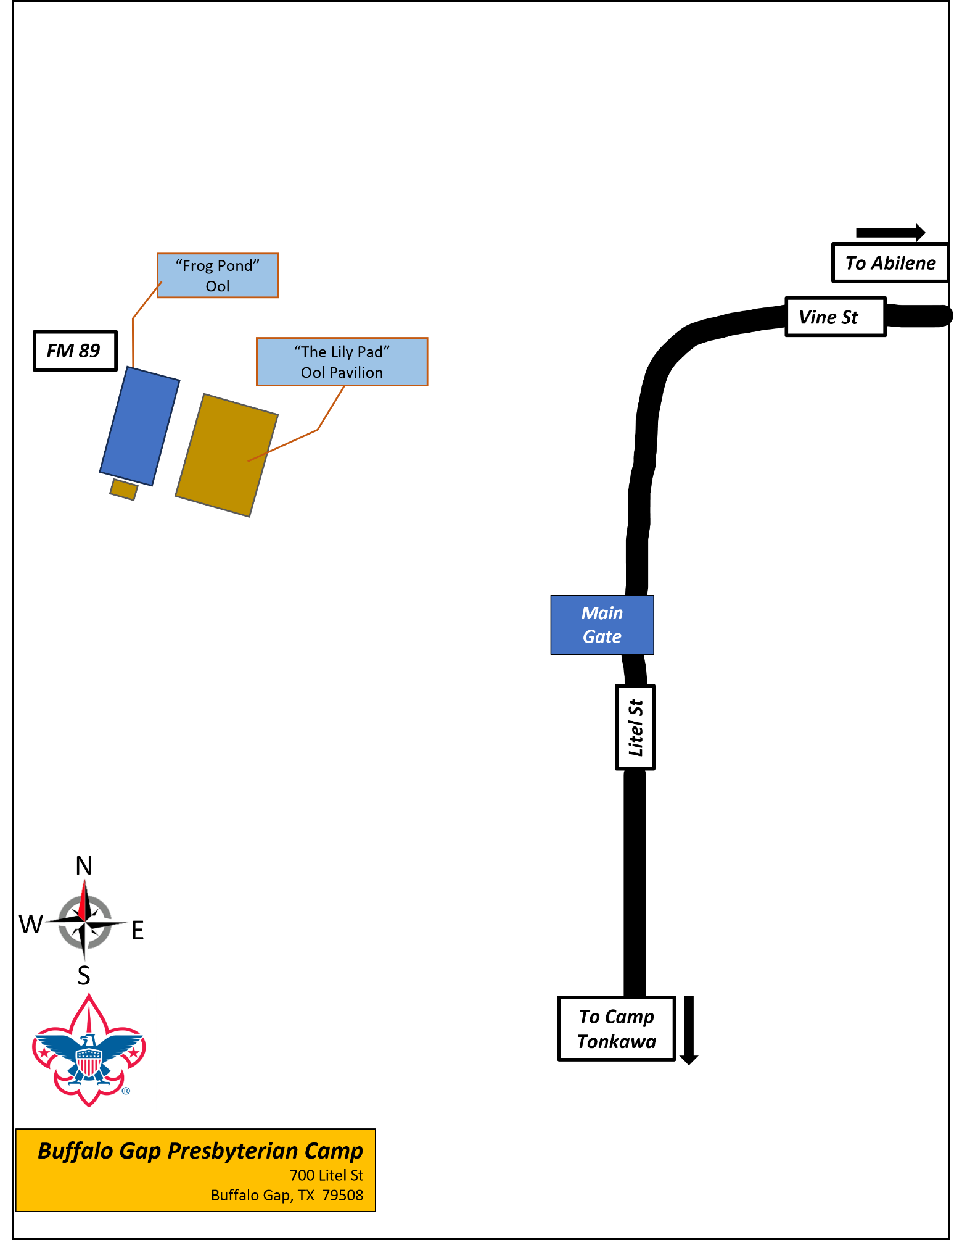

CUB SCOUT DAY CAMP REGISTRATION FORM

June 11 – 12, 2026

Leaders can register campers as a group or Individual campers may submit their paperwork to the office. Each Den must have one adult leader for each 4 campers. The maximum size of each den is 12 Scouts.

Pack # _____________________ Date __________________

 | ## | BEFORE June 10, 2026
# Of Scouts |  | X 25.00 | =
# Of Adults |  | X 10.00 | =
# Of Youth Volunteers |  |  | =
TOTAL FEES

Adults Name | Position | T-Shirt Size | Phone Number | Fees Paid
Youth Name | Rank | T-Shirt Size | Phone Number | Fees Paid

CUB SCOUT DAY CAMP
SPECIAL NEEDS REQUEST

REQUEST FOR PHYSICAL ARRANGEMENTS ASSISTANCE
****INCLUDES SPECIAL DIETARY REQUESTS****
MUST BE RETURNED BY June 8, 2026
Please Print or Type

Pack Number: __________ District: ___________________ Council: _________________

Unit Leader Making Request: _________________________________________________
Phone #:(_______) ____________________ Email: ______________________________________
Request made for (Name of Person): ________
Age: ______________
Type of Physical Arrangement, Assistance Requested or Special Dietary Request:

FOR COUNCIL USE ONLY

Date Filed with Council Office: ____________ Copy to Camp on: ___________________

Copy to Dining Hall Coordinator: _________________________________

Texas Trails Council, BSA
3811 North 1st Street
Abilene, Texas 79603
325-677-2688

RELEASE AND INDEMNITY/HOLD-HARMLESS AGREEMENT

I understand the use of facilities owned by Texas Trails Council, BSA involves a certain degree of risk that could result in injury or death. In consideration of the benefits to be derived and after carefully considering the risk involved and in view of the fact that the Boy Scouts of America is a not-for-profit organization:

RELEASE AND INDEMNIFICATION

I hereby release and waive any and all claims that I may have against Boy Scouts of America, Texas Trails Council, BSA and their employees, agents, representatives, or volunteers arising from use of their facilities. I AGREE TO FULLY INDEMNIFY AND HOLD HARMLESS BOY SCOUTS OF AMERICA, TEXAS TRAILS COUNCIL, BSA, AND THEIR EMPLOYEES, AGENTS, REPRESENTATIVES, AND VOLUNTEERS FROM ANY AND ALL CLAIMS ARISING FROM USE OF THEIR FACILITIES. THIS INDEMNIFICATION EXPRESSLY INCLUDES ANY CLAIMS ARISING OUT OF THE BOY SCOUTS OF AMERICA, TEXAS TRAILS COUNCIL, BSA’S OWN NEGLIGENCE OR FAULT OR THAT OF THEIR EMPLOYEES, AGENTS, REPRESENTATIVES, OR VOLUNTEERS. I AGREE THAT THE INDEMNIFICATION INCLUDES THE AMOUNT OF THE CLAIMS, THE EXPENSES OF DEFENDING AGAINST THE CLAIMS, COURT COSTS, AND ATTORNEYS’ FEES.

____________________________________________ ________________________
Adult Printed Name Date

____________________________________________ ________________________
Signature (if over 18 years of age) Telephone Number

List of your dependent children under 18 years of age.

First and Last Name of Dependent Child Relationship

____________________________________________ ________________________

____________________________________________ ________________________

____________________________________________ ________________________

____________________________________________ ________________________

____________________________________________ ________________________

____________________________________________ ________________________

