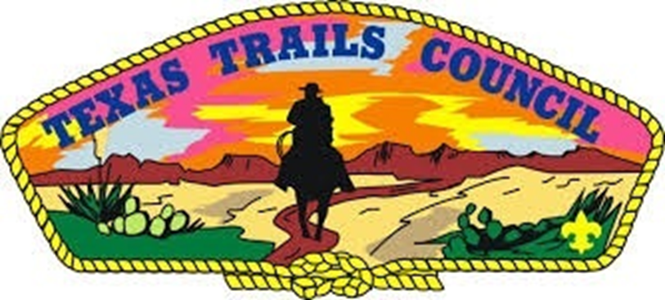

TEXAS TRAILS COUNCIL
Scouting America

Camp Billy Gibbons

Summer Mini Camp 2026
LEADER’S GUIDEBOOK, Version 3.0



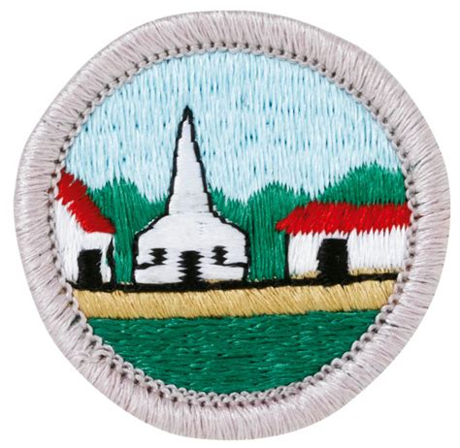

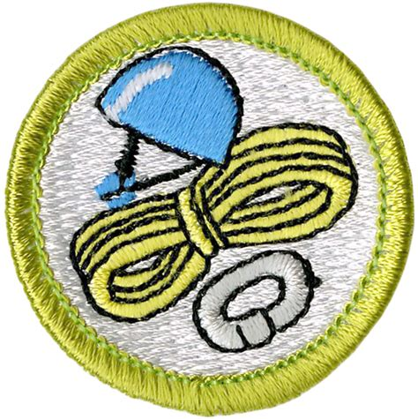
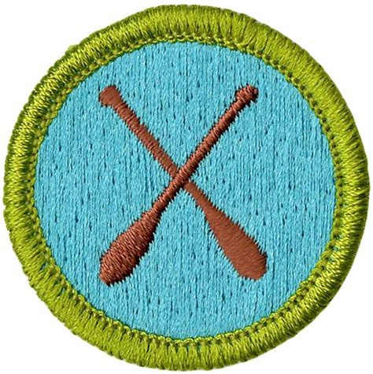

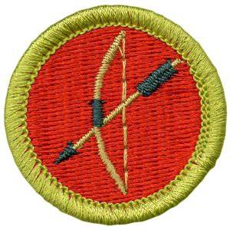
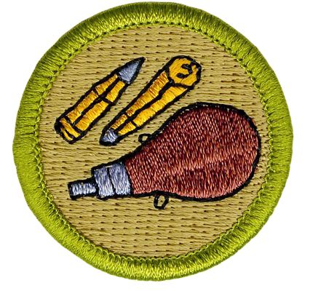

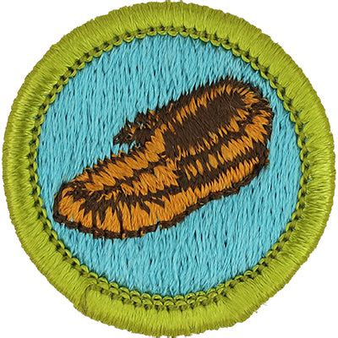


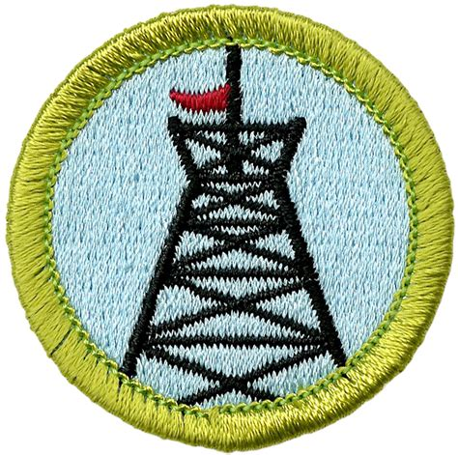
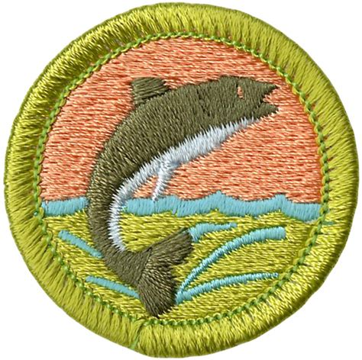
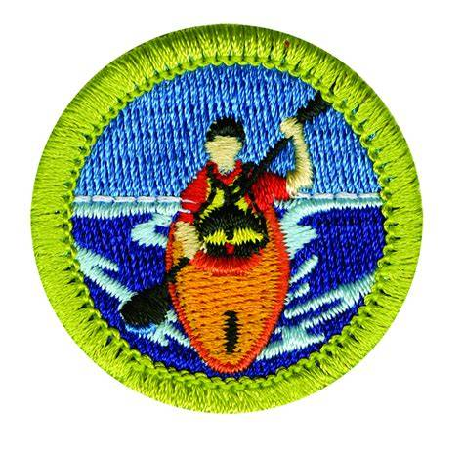
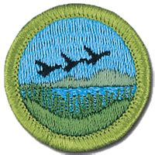


ABOUT THE CAMP
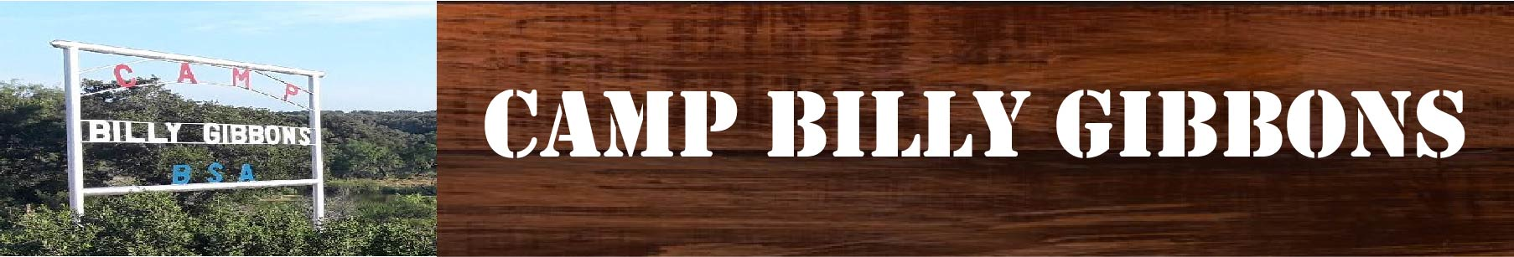

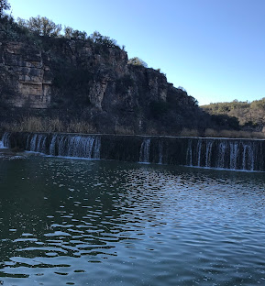

Camp Billy Gibbons is located on Brady Creek 13 miles south of Richland Springs, TX, and is one of the older camps in this area.
The camp is operated year-round and is used for summer camp, Order of the Arrow, Camporees, Junior Leader Training, Boy Scout Leader Basic Training, and weekend camping by Scout Troops.
Water and electricity are available only for official Council activities. A permit is required to use the camp. The first summer camp was held in 1931 at the “old” Camp Billy Gibbons located about three miles downriver from the “new” camp which held its first summer camp in 1947. Contact the Texas Trails Council if you would like more information on Camp Billy Gibbons for summer camp or make a reservation for your unit to camp out on a weekend.
- Camp Map Letter Size (8.5” x 11”)
- Camp Map Large Format (11” x 17”)
- Topographic Map
- History of Camp Billy Gibbons
- Texas Trails Council Property Usage Guidelines
TWO-DEEP LEADERSHIP
All units must have two (2) registered leaders or one (1) adult and a parent of a participating Scout, one of whom must be a least 21 years of age or older. Venture Crews must have two (2) leaders at least 21 years of age, one of which must be a female if the Crew is co-ed.
Male and female leadership require separate sleeping facilities. Married couples may share the same quarters if appropriate tents or facilities are available. Male and female youth participants will not share the same the same sleeping facility. NO YOUTH may stay in the tent of an adult other than his/her parent or guardian.
Youth and adults will not shower at the same time in the same facility. If separate shower and restroom facilities are not available, schedule and post times for youth/adult and male/female shower use. For restroom use, the buddy system should be utilized by having a person wait outside the entrance; or use “occupied” and “unoccupied” signs and/or inside door latches.

TRANSPORTATION
Seat belts are required for all occupants. Trucks may not be used for transporting passengers except in the cab. No person may ride in the bed of a truck even if it has a cab on it. Trailers must never be used for carrying passengers. Only licensed drivers at least 18 years of age may drive a vehicle in camp. A licensed youth member at least 16 years of age may be a driver, provided an adult who is at least 21 years of age is in the vehicle with the youth and provided the youth has at least six (6) months of driving experience as a licensed driver (not a Learner’s Permit).
All cars and trucks must be parked in the parking lot AT ALL TIMES during special activities, including Order of the Arrow, Camporees, Summer Camps, Training Courses, etc. Vehicles are allowed in campsites to unload and load equipment.
CAMP PROGRAM FACILITIES
All swimming activities must be conducted according to the Safe Swim Defense Plan. All boating and/or canoeing activities must follow Safety-A-Float and ALL persons in a boat or canoe must wear a Personal Floatation device (PFD) at all times. Rifle Range must be used under the supervision of a currently certified NRA rifle instructor who is 21 years of age or older. Prior permission for the use of the range must be obtained from the Council.
CAMP PROPERTY
Units should camp only in established campsites unless otherwise authorized by the Council Office. Fires are to be built in established areas and under constant supervision. All trash and garbage must be taken home with you as we have no trash dump. No flames in tents. Only flashlights and electric lanterns are permitted in tents. Chemical stoves and lanterns may be used in camp (but not in tents) only with knowledgeable adult supervision. Keep campsite neat and clean. Restrooms must be swept out and cleaned. No trash should be thrown in latrine pits. Latrine seats should be cleaned and closed. Urinals should be cleaned of any debris. Water faucets are to be turned off in the summer. Any damages should be reported to the Council Office.

CONSERVATION
Protect wildflowers, trees, and wildlife. Do not cut trees or use chainsaws without the permission of the Council Office. Only trees that have been specially marked by the Council may be cut or trimmed. Do not ditch tents or otherwise alter the terrain. Units are encouraged to complete a conservation project. Chainsaws may only be used by persons 21 years of age or older wearing proper safety gear. Eighteen to twenty-year-olds may use chain saws under proper supervision by an adult 21 years of age or older.
INSURANCE
The Texas Trails Council carries Camper’s Accident and Sickness insurance. Contact the Council Office for additional information on the insurance.
DO NOT BRING PROHIBITED ITEMS
Any alcoholic beverage or controlled substances, fireworks, dogs or pets of any kind, firearms, ammunition, or archery equipment.
Adult leaders should support the attitude that young adults are better off without tobacco and should not allow the use of tobacco products at camp.
IMPORTANT NOTICE FOR ADJACENT PROPERTY
The private property (Sorrell Ranch) on the other side of Brady Creek is OFF LIMITS to Scouts, etc. unless prior permission is obtained from the OWNERS. Contact the Council Office for details. Any group, regardless of its size, must be under adult supervision at all times and may not be on the ranch during hunting season for safety reasons. NO fires or overnight camping is permitted. All gates, water systems, etc. must be left alone or left as they are found. Bring back all trash with you. No hunting or fishing is allowed on the ranch.

MERIT BADGE PROGRAM


Merit Badge classes form the backbone of the program at Camp Billy Gibbons. Each day is divided into 3 Block Periods of class instruction time during the day. With over many different classes to choose from, your scouts will be sure to find classes that will suit their needs. Each of our classes are taught by highly qualified staff dedicated to helping scouts earn their requirements. At CBG we pride ourselves on our commitment to providing your troop with the opportunity to complete your badge, staff are available to provide campers with extra instruction if it is needed.
Advancement is an integral part of Scouting and as such is important to any successful camp. The following are guidelines for planning your Scout’s trail during your stay at Camp Billy Gibbons. There are two essential thoughts to keep in mind while counseling those who plan to attend camp:
1) the individual scout’s skill and desires
2) the schedule of times needed to complete any badge. Please be sure to counsel each scout individually noting the prerequisites that merit badges may have. These prerequisites are given to assist you and the Scout in completing the skill.

ADVANCEMENT PROGRESS

Check in the program areas about your Scout’s progress as you feel necessary. During camp, you are encouraged to visit the program areas and discuss your Scout’s progress with the instructors.
Only through counseling can you determine what badges a Scout needs to work on or in which they have the desires and skills. Here are some crucial steps in the planning process.
- A scout’s physical skill needs to be considered especially in the aquatic badges. In shooting sports, the experience of shooting, archery, rifle, and shotgun need to be considered.
- Scouts should come to camp having read the requirements and reviewed the Merit Badge Book. Prerequisites should accompany them to their first class.
- Merit Badge applications should be readied prior to camp arrival, including signatures.
- Scouts who come prepared will be able to finish the badge in less time having additional time for open areas and Troop programming. Please be sure to carefully review pre-requisites for each Merit Badge.

PARTIAL COMPLETION

For all merit badges, a scout will receive a partial statement if they have completed any of the requirements. The partials will state the requirements that the Scout has accomplished. The philosophy behind a partial is for a scout to return home and complete the badge as soon as possible. The counselor has the right to review all the completed requirements before signing for the merit badge.
Some merit badges allow for options to be chosen by the scout. Some options are NOT available at camp. Scouts who choose an option not available will be given a partial for work completed at camp.
MERIT BADGE PRE-REQUISITES/REQUIREMENTS NOT AVAILABLE AT CAMP
Scouts should prepare for class by reading the requirements for the merit badge classes they have chosen. Every Scout shall come to each class prepared. Bring a pencil and any equipment suggested in the merit badge pamphlet. A Scout may want their own merit badge pamphlet. Merit Badge pamphlets will be available for purchase in the Trading post. Merit Badge requirements NOT available at camp may be completed prior to arrival. Proof of a requirement that has been completed prior to camp, MUST be notated by the Scoutmaster, and given to the MB counselor prior to the final day of class. This will allow the counselor to sign-off the completion of the badge.
If prior MB work is not notated and given to the counselor, the scout will only receive a PARTIAL for the work completed at camp.
MERIT BADGES OFFERED

Merit Badge | Scheduled Instructor
Archery | Mel Jones
Canoeing | Isabella McCutchin
Chess | Colton Rasbury
Citizenship in the Community*** | Colton Rasbury
Climbing | Nathan Williams
Emergency Preparedness*** | Alvin Stuart
First Aid*** | Alvin Stuart
Fish and Wildlife Management | Marie Jones
Fishing | Randal Hawkins
Geology | Marie Jones
Kayaking | Isabella McCutchin
Leatherworking | Christi Price
Personal Management*** | Colton Rasbury
Pioneering | Steven Sim/Cory Smith
Public Speaking | Michael Brown
Rifle Shooting | Mel Jones/Alvin Stuart
Soil and Water Conservation | Marie Jones
Sustainability*** | Marie Jones
Woodcarving | Christi Price

***Eagle Scout Required
More classes may be added based upon staffing and requests. Want to teach a class period or more contact Michael Brown to get it added.
The merit badges listed above are planned and scheduled for Scouts BSA Mini Camp 2026. The camp reserves the right to cancel, reschedule or otherwise change the merit badge offerings during the camp session.
Every attempt will be made to fulfill the schedule of all merit badges. Please understand that staffing and/or resources may be unavailable to realize all merit badge classes.

Class assignments will be schedule during the Check-in Process

EVENT SCHEDULE

Day 1 (June 4th)

17:00 – 20:00 Check In/Final Registration/Campground Setup
20:00 – 20:30 Opening Prayer
20:45 – 21:15 Cracker Barrell and SPL and Leaders Meeting
21:15 – 23:00 Opening Campfire
23:00 Lights Out

Day 2 (June 5th)

07:20 – 07:30 Flag Ceremony
07:30 – 08:30 Breakfast
08:30 – 09:00 Open Time
09:00 – 12:30 Morning Merit Badge Sessions
12:30 – 13:30 Lunch
13:30 – 15:00 Early Afternoon Merit Badge Sessions
15:00 – 17:30 Late Afternoon Merit Badge Sessions
17:30 – 18:00 Open Time
18:00 – 18:10 Flag Ceremony
18:10 – 19:00 Dinner
19:00 – 22:00 Troop Specific Activities
23:00 Lights Out

Day 3 (June 6th)

07:20 – 07:30 Flag Ceremony
07:30 – 08:30 Breakfast
08:30 – 09:00 Open Time
09:00 – 12:30 Morning Merit Badge Sessions
12:30 – 13:30 Lunch
13:30 – 15:00 Early Afternoon Merit Badge Sessions
15:00 – 17:30 Late Afternoon Merit Badge Sessions
17:30 – 18:00 Open Time
18:00 – 18:10 Flag Ceremony
18:10 – 19:00 Dinner
19:00 – 22:00 Troop Specific Activities
23:00 Lights Out

Day 4 (June 7th)

07:20 – 07:30 Flag Ceremony
07:30 – 08:30 Breakfast
08:30 – 09:00 Open Time- Camp Breakdown
11:00 – 11:10 Flag Ceremony
11:10 – 11:30 Checkout and Departure

2026 Camp Billy Gibbons Menu

Day 1 (06/04)
PM: Cracker Barrel – Fruit, Cheese, Veggies, and Crackers
Day 2 (06/05)
AM: Happy Campers (Eggs, Toast, Meat Gravy) and Fruit
Noon: Potato Bar - Dessert
PM: Roasted Chicken and Veggies – Dessert
Day 3 (06/06)
AM: Oatmeal Bar - Fruit
Noon: Hot Dogs/Sausage on Stick and Veggie Bar - Dessert
PM: Camp Fried Rice - Dessert
Day 4 (06/07)
AM: Camp Billy Griddles (Pancake/Sausage) and Fruit

REFUND POLICY
Units are asked not to over reserve places for Scouts and leaders. This often means that others will be denied spaces, which would have otherwise been available. There are no refunds for “no shows”. Only medical emergencies will constitute a valid reason for a refund. $50.00 is not refundable in any case. The Council will credit refunds to the Unit’s, Unit Account at the Council Service Center for use by the Unit for Scout Shop purchases, registrations and Boy’s Life fees, or event, activity, and training fees.
If a Scout or leader becomes ill while attending camp and is sent home by the camp medical staff, they are eligible for a pro-rated refund (by day) of the “balance of fee.” (Remember $50.00 is non-refundable.) If a camper leaves without being sent home by the camp medical staff, there is NO refund.
All refunds and overpayments will be processed after camp has been balanced by the Council Service Center. All refunds and overpayments will post to the Unit’s Account at the Council Service Center. A notification of the deposit will be emailed to the Unit Leader and Committee Chairman.

REGISTRATION REQUIREMENTS
The Texas Trails Council, Boy Scouts of America provides programs, facilities, and services without regard to race, color, national origin, age, gender, or handicap. However, all leaders and youth on the camp must be current registered members of the Boy Scouts of America. All part-time leaders that will be camping overnight on the camp must be current registered members of the Boy Scouts of America.
No camper (Youth or Adult) will be permitted to stay in camp unless their full camp fees have been paid prior to the start of their camp session.

CAMPERSHIPS AND FINANCIAL NEED

Financial aid is available to help Scouts and families in need of financial assistance. Campership Application forms are available at the Texas Trails Council office and in this guide. Financial aid is not designed to pay the entire camp fee for the Scout. The family, pack, and/or chartering institution should pool their resources first with a financial aid request designed to meet the balance required. Remember, every Scout should be able to attend camp regardless of his personal financial circumstances. Thank you notes from those who receive aid are appreciated.

STAFF VOLUNTEERS

We are always looking for great people that live by the Scout Oath and Scout Law to volunteer in several positions. So, if you are interested in volunteering during your week at camp, please fill out the volunteer application and submit to schedule an interview or just let us know when you arrive at camp.
CAMP SERVICE
The Camp Office is open daily. The following are important things to know about the office.
- "Lost and Found".
- All Scouts and leaders must check-in and out with the office when coming to or leaving camp. See the check-in and check-out procedures.
- Toilet paper and hand soap for each campsite is available in the Camp Office.
- Report any emergencies to the Camp Office immediately. Office staff will notify the proper personnel.
- Incoming telephone messages are placed in your campsite's mailbox in the office.
- All incoming mail for your unit will be handed out at lunch or evening flags.
- Letters and postcards can be mailed from the Camp office.
- Scouts are asked to stay out of the Camp Office except in cases of emergency, unless accompanied by an adult.

WHAT TO BRING

- Bandana
- Canteen, Nalgene (for water)
- Clothes (shirts, shorts/pants, socks, and undergarments)
- Compass
- Flashlight
- Hat
- Jacket
- Medications (if any is taken daily, and it will be turned into the Camp Medic)
- Personal First Aid Kit (Scouts need to bring this for the First Aid MB)
- Personal Hygiene Products (showers are available)
- Pocket knife (if scouts have already earned their Totin’ Chip)
- Rain gear
- Shower shoes
- Sleep wear
- Sleeping gear (cot, pad, sleeping bag, blanket, sheets, pillow, etc.)
- Small day pack
- Sturdy shoes (No open-toe Shoe)
- Sunscreen
- Tent
- Towels
- Uniform
- Optional Gear
  - Camp chair
  - Fire starter
  - Hiking stick
  - Insect repellent
  - Lantern
  - Notebook/pen
  - Sunglasses
  - Watch

MEDICAL TREATMENT NOTES
The Health and Safety of all Scouts and Leaders attending Camp is the priority of our operation while they participate in outdoor programs at our summer camps. The following information is provided to familiarize you with camp medical policies and procedures.
PHYSICAL EXAMINATIONS - All Scouts and Leaders going to camp must, upon arrival, present a completed Part A and B (B1 and B2) to the Camp Health Officer. A link is provided for the BSA Annual Health & Medical Record, Form 680-001, on the Texas Trails Council website.
NON-EMERGENCY TRANSPORTATION - Each Unit must provide transportation to and from the Local Health facilities in non-emergency situations. If transportation is not available from the Unit, check with the Camp Director or Health Officer for assistance.
PRESCRIPTION MEDICATION – All prescription medication will be kept in the Camp Health Lodge unless it is an Epi-Pen, rescue inhaler or other “immediate need” medication. Also, please note that needles used for insulin injections or other prescribed medications must be placed in the biohazard container located in the health lodge. The Health Lodge will provide cold storage for medications requiring refrigeration.
SPECIAL NEEDS - Any Scout or Leader with needs that require accommodation while at camp, need to tell us well in advance of those services of the type of need, i.e. physical, medical, dietary, food allergies, etc. Food allergies and dietary requests should be turned in two weeks prior to camp. Please use the “Special request” form located in the appendix of this guide.
UNIT FIRST-AID KITS - Everyone should be familiar with basic first aid. It is important that each Unit be prepared to treat minor cuts, scrapes and abrasions. Bandaged wounds should be kept clean to aid in preventing infection, especially in an outdoor setting. The following is a list of recommended contents for a Pack first aid kit:
One 4” Roll of Bandage | One 2” Roll of Bandage | Two Rolls of 1” Tape
Two Triangular Cravats | Four Elastic Bandages | Antibacterial Soap
One Box of Assorted Band-Aids | Twelve 4x4 Sterile Pads | Scissors
Six Pairs of Latex Gloves | Twelve 2x2 Sterile Pads | Needle and Tweezers
Safety Pins | Sunburn Lotion | Tylenol/Non-Aspirin Tablet
Index Cards | Scotch Tape
USAGE POLICY OF MOTORIZED CARTS
From time-to-time, youth members with disabilities may have a challenge with the amount of foot-travel that is required to participate in the programs at Camp and need special assistance in the form of a motorized cart while at camp. To protect all Scouts and Leaders while in Camp, the following guidelines have been established for the use of motorized vehicles such as golf carts, electric scooters, etc. for transportation of individuals with limited mobility. On Scout’s Camp Physical, the need for a motorized vehicle must be noted by the signing physician and Any person needed this request should be turned in by May 25th, 2026. Please use the “Special request” form located in the appendix of this guide.
- Personal vehicles are not allowed, unless is it designed specifically for a scout with a disability. Personal vehicles must be inspected by the Health Lodge and Camp Ranger prior to being used at the camp so that it can be determined safe to operate on the terrain found at both of our camps. Not all motorized vehicles are designed or are safe in this environment and could put a scout at risk of injury. When a personal vehicle is used, a Certificate of Liability Insurance covering the vehicle must be presented. This Certificate should name the Council as a co-insured.
- The assigned driver of the vehicle shall be over the age of 21 and the youth member shall not operate the vehicle by themselves.
- The vehicle is solely for the transporting the Scout with a disability. Additional riders or operating the vehicle for other purposes will NOT be permitted.
- The camp will NOT provide vehicles for use.
- Adults may bring their own vehicle to camp if the following criteria are met:
  - Their Camp Physical states that they need this type of assistance.
  - It is inspected by the Health Lodge and Camp Ranger to determine it appropriate design for the terrain of the reservation (Gators, mules, or any other type of UTV will not be allowed)
  - It is for the sole use of the owner. Additional passenger, drivers or scouts will not be allowed to ride or operate it.
  - Certificate of Liability Insurance which names the Council as a co-insured is presented.

TRADING POST
The Trading Post is stocked with various souvenirs, T-shirts, patches, camping gear, writing materials, stamps, refreshments, and toilet articles. The following hours of operation are subject to change due to staffing and camper traffic. The trading post is open after morning flags until approximately 8:30pm each evening. The specific hours of the trading post will be announced and posted.

SPENDING MONEY - It is suggested that Scouts bring spending money to camp. We have a very well stocked Trading Post. Some Scouts bring approximately $50 or a prepaid credit card to camp. Troops may wish to operate a "bank" to hold money for Scouts while at camp. Only small bills $1s, $5s & $10s should be brought to camp. The Trading Post cannot easily make change for larger bills. The Trading Post also can process Credit Card payments for purchases over $10.00 plus a 5% Service Charge! There will be NO Unit or personal IOU Taps started without the approval of the Camp Director!

All personal items and spending money should be kept in a secure camp box while at camp. Clothing should be clearly marked with your full name and Troop number. The Texas Trails Council, Camp Billy Gibbons and Staff are not responsible for securing or for the loss of personal items. It is your responsibility to keep track of all personal valuables while at camp.

DRINKING WATER AND ICE
Drinking lots of water instead of soda is important during hot weather. Scouts should be encouraged to drink at least one gallon of water a day outside of meals. Each program area will have a water cooler for convenience. Units are encouraged to bring water coolers to camp and keep them filled with ice water. Ice is available at the dining hall.

RULES AND REGULATIONS AT CAMP
GENERAL SAFETY TIPS
- Always hike in groups of three or more. Scouts need their leader’s permission before going hiking. Note their route and ask them when they plan on returning to the campsite.
- Closed-toe shoes are Required on Camp, In and Out of the Campsite to prevent cuts and bruises (no sandals).
- Keep the latrine and campsite areas clean and free from hazards.
- Place trash in waste receptacles and recycle when possible.
- If you need to Leave Camp for Any Reason, please Sign Out at the Camp Office and Sign back in once you arrive back on Camp.
- STAY OFF, the rappelling tower when area is closed.

ALCOHOLIC BEVERAGES & NARCOTIC DRUGS
The Texas Trails Council will NOT tolerate the presence and/or use of alcoholic beverages, narcotics, drugs, or persons obviously under the influence of same, at any of our Council Camps. Violators will be asked to leave camp immediately. Leaders are expected to set an example for their boys to follow. Please announce to all parents coming to Camp as part-time leaders, or visitors, that alcoholic beverages are banned from Camp Property.

SMOKING AND TOBACCO POLICY
THE USE OF ANY FORM OF TOBACCO IS PROHIBITED on any Part of the Camp Property. Please See the Camp Ranger if you Have any Questions.

FIREWORKS, FIREARMS AND WEAPONS
Fireworks are NOT permitted at camp. Fireworks will be confiscated, and destroyed by the local fire marshal, and your unit may be asked to leave camp. Please make sure that your boys do NOT bring any fireworks to camp.
Personal firearms, archery equipment, and sheath knives are not allowed in any area of camp including the archery and rifle ranges. If brought to camp, these items must be turned into the Camp Ranger until the Unit checks out at the end of the camp session. Experience over the years has taught us that boys and sheath knives are not a wise combination. Please ensure that this type of personal equipment is left at home, and not brought to camp by your boys or adult leaders.

FIRE PROTECTION

In case of fire, notify the Camp Office immediately. Do not attempt to fight any fires yourself! Ground fires are allowed in the campsites after being approved by the Camp Ranger.

LIQUID FUEL POLICY
The use of liquid or jellied fuels such as gasoline, oil, sterno or kerosene for lighting, cooking, generators, or other motors other than automobiles is prohibited at camp. The storage of any type of liquid fuel in pack campsites is not allowed and strictly prohibited. The council health and safety, risk management, and camping committees have agreed that the storage and/or possession of such fuels constitute a safety hazard to our Scouts at camp. There will be no exceptions to the above policy.

Campership Application
Due Date: 05/28/2026
- Please PRINT all information. Parent and or guardian must complete ALL information. Unit Leader must sign this application.
- Application must be mailed to: Texas Trails Council, BSA, 3811 North 1st St., Abilene, TX 79603.
- Completion of this form DOES NOT guarantee a campership. Camperships are made based on verified need, Scout popcorn sales, family help, troop help, and chartered organization help and based on funds available.
- Campers must be currently registered in the unit stated on this application and must be attending a Texas Trails Council, BSA summer camp during the CURRENT summer season.
- The maximum amount of campership funds granted is 33% of the total camp fee, although a greater amount may be granted under exceptional circumstances if available. A granted campership in the applicant’s name that is not used in the current year is not transferable to the following year.
- Approved applicants will be notified in writing.
Unit Type: ________ Unit Number: ______District: ______ Date of Application: __/__/___
Applicant Name: ________________________________________________ Date of Birth: ____________
Parent’s/Guardian’s Name ________________________________________ Phone: _________________
Address: _______________________________________City: _____________________Zip __________
Dates attending camp: From: ________________________ To: _________________________________
___ Cub Scout Day Camp ___ Scouts BSA Resident Camp
Total Household Income ___ under $25,000___ $25,000 - $50,000___ $50,000 - $75,000___ over $75,000
Reason for Campership Request:
_____________________________________________________________________________________________
______________________________________________________Signature_______________________________
Total Camp Fee $ ______________________
Scout’s share of camp fees (Popcorn/Camp card sales/fundraising) $ ______________________
Family’s share of camp fees (Required) $ ______________________
Share of camp fees from unit (Required) $ ______________________
Share of camp fee from Charter Partner or another source $ ______________________
Amount requested from the Campership fund $ ______________________
Certification: I hereby certify that to best of my knowledge, the reason given for this campership request is accurate. Two signatures are required – Unit Leader and Committee Chairman or District Representative.
Print name: _________________________________ Signature: _________________________________
Print name: _________________________________ Signature: _________________________________
Office use only
- Application approved for: $ _______________Date: _________________________ Initials: _______________
- Application NOT approved. Date: _________________________ Initials: _______________

Scouts BSA RESIDENT CAMP
ACCOMODATION REQUEST

REQUEST FOR PHYSICAL ARRANGEMENTS ASSISTANCE
****INCLUDES SPECIAL DIETARY REQUESTS****
MUST BE RETURNED TWO WEEKS PRIOR TO CAMP
Please Print or Type

Unit Number: __________ District: ___________________ Council: _________________

Unit Leader Making Request: _________________________________________________
Phone #: (_______) __________________ Email: ____________________________________________
Request made for (Name of Person): _______
Age: ______________
Type of Physical Arrangement, Assistance Requested or Special Dietary Request:

_ _ _ _ _ _ _ _ _ _ _ _ _ _ _ _ _ _ _ _ _ _ _ _ _ _ _ _ _ _ _ _ _ _ __ _ _ _ _ _ _ _ _ _ _ _ _ _ _ _ _ _ _ _ _
FOR COUNCIL USE ONLY

Date Filed with Council Office: ____________ Copy to Camp on: ___________________

